Problem 5)

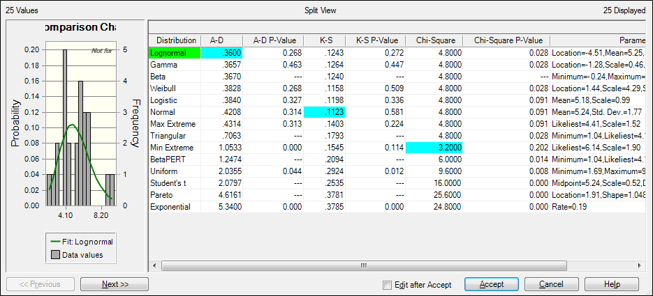



The test value (0.549912) is less than the critical value chose with alpha = .1(1.224)

Therefore we do not reject the null hypothesis similar to how we did not reject in the previous test.